 



**ONLINE COURSE:**

**BARCELONA SCREENING SCHOOL - CERVICAL CANCER SCREENING**

**M1 Cancer prevention - Author Templates**

# Highlights of the course

|  |  |
| --- | --- |
| Total modules | 8 modules |
| Approximate Hours | Total hours: 27,5 hours  Module 1: 2,5 hours  **Module 2: 2,5 hours**  Module 3: 4 hours  Module 4: 1,5 hours  Module 5: 8 hours  Module 6: 2,5 hours  Module 7: 1,5 hours  Module 8: 5 hours |
| Total number of pages to produce approximately | **Module 2: 12,5 word pages (not counting final evaluation,** **glossary and Bibliography)** |
| Number of characters per page | Five word pages of text correspond to one hour of online training.  Each page will be of 2,100 characters in Arial 10, 1.5 line spacing. |
| Delivery Date |  |
| Language | Preferably English |

BIOGRAPHICAL SKETCH OF THE AUTOR

Paula Peremiquel-Trillas holds a medical degree (Autonomous University of Barcelona, 2014) and a Master degree in Public Health (Pompeu Fabra University, 2017). She is specialized in Preventive Medicine and Public Health (Vall d’Hebron University Hospital, 2019). During her specialization training she has done internships in the World Health Organization and in the Catalan Institute of Oncology (ICO) and she has been involved in different research projects in the field of vaccinology, virology, cancer epidemiology and community health. In May 2019, she joined the Cancer Epidemiology Research Program (CERP) at ICO as epidemiologist working on the Screenwide Project while working on her PhD. Since 2020 she is also a sub investigator in the randomized clinical trial evaluating the efficacy, immunogenicity and safety of 9v-HPV vaccine versus placebo in preventing persistent oral infection in adult men.

Laura Costas is a medical doctor (Autonomous University of Barcelona – 2005) and holds a Master of Public Health (Pompeu Fabra University, 2006). In 2010, she obtained the Emili Letang End-of-Residency award from the Clinic Hospital in Barcelona, after her training in preventive medicine and public health. She holds a PhD in medicine from the University of Barcelona at IDIBELL (2012-2016). In her PhD, she studied the role of reproductive factors, hormone use and endocrine disruptors in the etiology of lymphoid neoplasms, under a Rio Hortega grant. In 2012, she spent a year at the McGill University in Montreal (Canada) and got a valuable experience on the quantitative analyses of biases in epidemiologic studies. In 2016, she performed a research stay at the Genomic Cancer Susceptibility group at the International Agency for Research on Cancer (IARC), in Lyon, France. In 2016 she joined the Catalan Institute of Oncology serving as a researcher for a project on early detection of endometrial and ovarian cancer based on the genomic exploitation of minimally invasive sampling methods, such as cervical cytologies and vaginal self-samples.

**Structure of the course (12,5 pages)**

* + Introduction and Learning Objectives
  + Index
  + Contents
  + Summary

**Module 2: Cancer prevention**

# Title: Introduction and Learning Objectives

**[Introduction]**

In this module you will learn different cancer prevention strategies, with a special focus on screening. You will be able to distinguish the most important aspects of a screening programme and the characteristics of opportunistic and organized programs. You will increase your knowledge on the criteria a good screening test needs and the overall program characteristics.

**[Learning Objectives]**

At the conclusion of this course, participants will be able to:

* Identify the different types of cancer prevention.
* Understand cancer screening characteristics: principles of screening, types of screening programmes), screening test characteristics, and overall requirements for screening programme implementation.

**[Index]**

1. Basics

1.1. Natural history of the disease and types of cancer prevention

1.2. Intro to the European Code against Cancer

1. Principles of screening

2.1. Opportunistic vs organized screening programs

2.2. Wilson and Jungner 10 principles of screening

2.3. Potential biases (lead time, length time, overdiagnose, etc)

1. Test parameters and requirements

3.1. Criteria for a good screening test

3.2. Test accuracy and reliability

3.3. Screening vs triage tests

1. Overall program characteristics

4.1. Acceptability and safety

4.2. Cost-effectiveness

4.3. Quality control

4.4. Impact evaluation

**Module 2: Cancer prevention**

# Unit: 1.

The natural history of disease is the progression of a disease over time. Many diseases have certain relatively well-defined and well-known stages. The types of prevention depend on the stage of the natural history of the disease at which we apply the preventive measures.

[Figure 1]

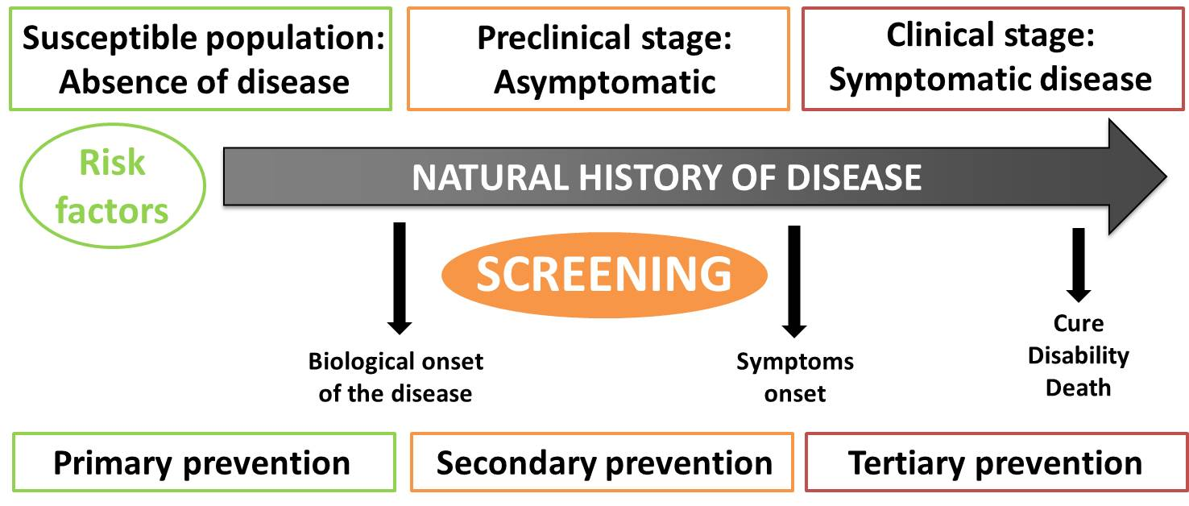

The disease process begins with the exposure to risk factors in a susceptible host in our case exposure to oncogenic HPV types (1).

After this, the disease process is triggered and pathological changes start, normally without the individual being aware of them (asymptomatic). This is known as the subclinical stage of disease or the latency period. This period in cervical cancer can take decades. Although disease is not apparent, pathological changes can be detected with different methods (cytology, testing of the risk factor HPV),

setting the importance of screening, since intervention at this stage is likely to be more effective. After this period, the diseases start to be symptomatic and it is when individuals look for medical assistance. The presentation and course of cancer will vary in different individuals and contexts, even for the same disease. In some, the disease process may never progress to cancer. In others, the process may result in severe or fatal illness. This is called the spectrum of disease. Ultimately, the disease process ends either in recovery, disability or death.

[Example] For cancer, the exposure may be a factor that initiates the process, such as asbestos fibres or components in tobacco smoke (for lung cancer) and exposure to HPV (for cervical cancer) among others. After those exposures, changes in the host start and they are imperceptible for such long periods of time. In this moment is when screening is possible to early detect the disease before symptoms start.

*Primary prevention* (2) focuses on protecting healthy individuals from the biological onset of disease. Therefore, primary prevention strategies aim to reduce the incidence of disease by eliminating exposure to risk factors or by increasing population resistance to risk factors. Primary prevention includes health promotion and health protection interventions. In cervical cancer the main primary prevention action will be to avoid HPV exposure through vaccination.

*Secondary preventio*n (screening) (2), consists of the systematic application of safe, easy-to-use and economically affordable tests, to provide early detection of disease (during preclinical stage) followed by timely treatment. Secondary prevention objective is to identify the existence of health problems before they get worse, when signs and symptoms of the disease are not yet apparent, to provide treatment at an early stage to improve disease prognosis. Screening aims at reducing the disease prevalence by shortening its duration, to reduce the incidence of complications associated with the disease and to increase the quality of life of those affected by the disease. In cervical cancer secondary prevention will consist on detection on precancerous lesions caused by the persistent infection of HPV

*Tertiary prevention* aims to decrease the impact of an ongoing disease. It consists of managing long-term disease to avoid complications and relapses of disease in order to reduce morbidity and disability in people diagnosed with, and being treated for, disease.

[Examples]

|  |  |
| --- | --- |
| *Primary prevention* | * HPV vaccination of oncogenic types * Condom use * Avoidance of sexual relations * Health information and warnings about tobacco use |
| *Secondary prevention* | * Detection of oncogenic HPV types * Detection of cellular morphological lesions * Detection of biomarkers linked to HPV oncogenes |
| *Tertiary prevention* | * Downstaging * Palliative care * Adjuvant treatments |

**[Did you know?]** A group of experts assessed the available evidence on cancer prevention to develop the European Code against Cancer, a list of 12 recommendations on actions that individual European citizens can take to help prevent cancer:

1. Do not smoke. Do not use any form of tobacco.
2. Make your home smoke free. Support smoke-free policies in your workplace.
3. Take action to be a healthy body weight.
4. Be physically active in everyday life. Limit the time you spend sitting.
5. Have a healthy diet:

* Eat plenty of whole grains, pulses, vegetables and fruits.
* Limit high-calorie foods (foods high in sugar or fat) and avoid sugary drinks.
* Avoid processed meat; limit red meat and foods high in salt.

1. If you drink alcohol of any type, limit your intake. Not drinking alcohol is better for cancer prevention.
2. Avoid too much sun, especially for children. Use sun protection. Do not use sunbeds.
3. In the workplace, protect yourself against cancer-causing substances by following health and safety instructions.
4. Find out if you are exposed to radiation from naturally high radon levels in your home. Take action to reduce high radon levels.
5. For women:

Breastfeeding reduces cancer risk. If you can, breastfeed your baby. Hormone replacement therapy (HRT) increases the risk of certain cancers. Limit use of HRT.

1. Ensure your children take part in vaccination programmes for:

* Hepatitis B (for newborns)
* Human papillomavirus (HPV) (for girls)

1. Take part in organized cancer screening programmes for:

* Bowel cancer (men and women)
* Breast cancer (women)
* Cervical cancer (women)

Yet, successful cancer prevention requires these individual actions to be supported by governmental policies and actions.

For more information on the European Code Against Cancer please check ADD REFERENCE (3)

**Module 2: Cancer prevention**

# Unit: 2. Principles of screening

Screening is the action of actively searching for a disease in an asymptomatic population. A disease should fulfill some

requirements before it is considered as candidate for screening (See Box).

Wilson and Jungner enumerated the following criteria that are key in understanding the complexity and requirements of a screening program to be considered before undertaken a screening program (8,9).

Classic criteria are:

1. The condition sought should be an important health problem.
2. There should be an accepted treatment for patients with recognized disease.
3. Facilities for diagnosis and treatment should be available.
4. There should be a recognizable latent or early symptomatic stage.
5. There should be a suitable test or examination.
6. The test should be acceptable to the population.
7. The natural history of the condition, including development from latent to declared disease, should be adequately understood.
8. There should be an agreed policy on whom to treat as patients.
9. The cost of case-finding (including diagnosis and treatment of patients diagnosed) should be economically balanced in relation to possible expenditure on medical care as a whole.
10. Case-finding should be a continuing process and not a “once and for all” project.

Besides these test classic criteria, additional criteria mainly considering programmatic issues are generally considered critical :

* The screening programme should respond to a recognized need.
* The objectives of screening should be defined at the outset.
* There should be a defined target population.
* There should be scientific evidence of screening programme effectiveness.
* The programme should integrate education, testing, clinical services and programme management.
* There should be quality assurance, with mechanisms to minimize potential risks of screening.
* The programme should ensure informed choice, confidentiality and respect for autonomy.
* The programme should promote equity and access to screening for the entire target population.
* Programme evaluation should be planned from the outset.
* The overall benefits of screening should outweigh the harm

The target disease should be an important health problem, for its frequency or for its severity. The natural history of the disease needs to be well-understood and there should be sufficient data on the incidence and prevalence of the disease in an specific setting, as well as evidence on the association between disease markers and progression (natural history of disease) and the implications (clinical, psychological, economical) of resulting positive in the screening test.

**Module 2: Cancer prevention**

# Unit: 3. Test parameters and requirements

## 3.1 Criteria for a good screening test

Screening tests are applied to subjects without clinical symptoms of disease; therefore any test needs to be evaluated carefully in order to limit the potentially negative consequences on health outcomes (delay at diagnosis, false positive results, etc) and health system expenditures.

Screening involves categorizing asymptomatic populations in four groups in relation to our gold standard (generally biopsy) and a screening test (in the example HPV test). On the graphic these four groups are

A) those with cancer that test HPV positive,

B) those without cancer that test HPV positive

C) those with cancer that test HPV negative and

D) those without cancer that test HPV negative.

A perfect test will classify women either in cell a or in cell D. But there are no perfect tests therefore our efforts will be directed to minimize false results like in B or C.

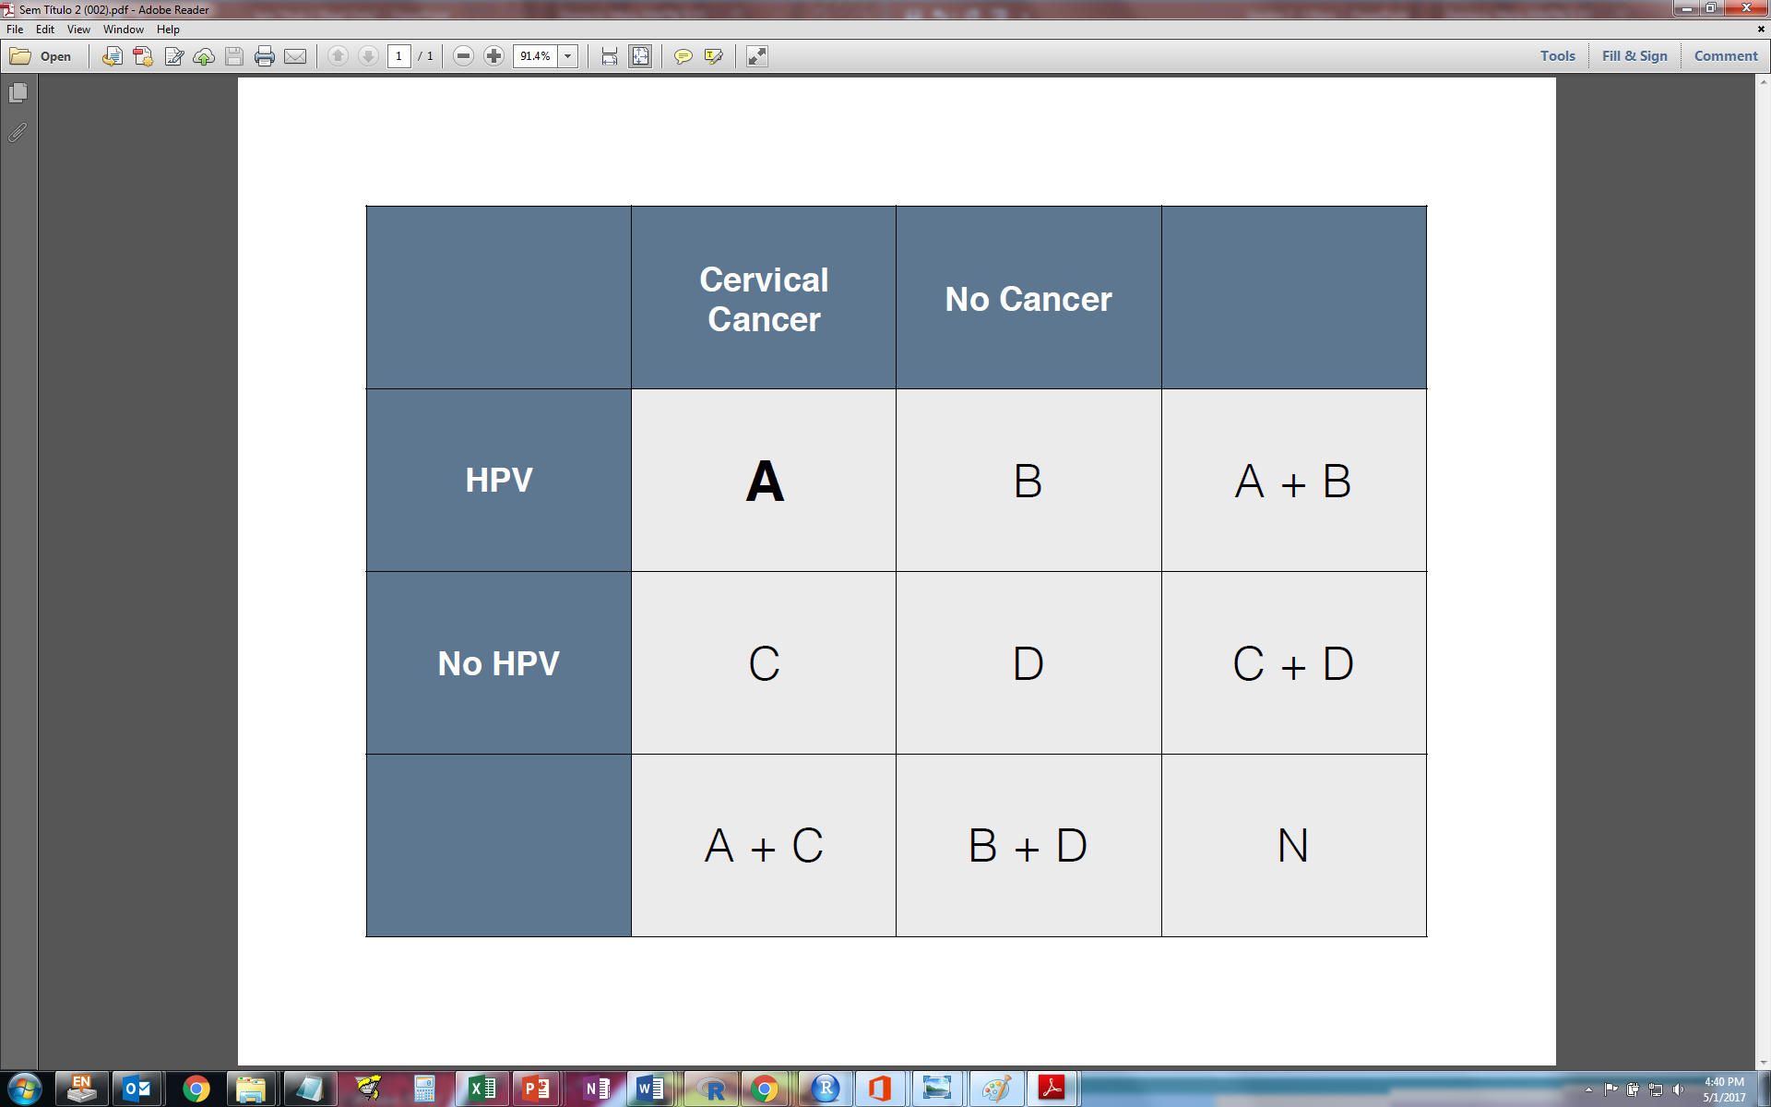

Therefore, a screening test needs to be (13):

* Accurate: the test is able to detect disease properly and classify correctly those who are ill and those who are not.
* Reliable / reproducible: the test can give the same result consistently when repeated/ and when performed in different settings.
* Cheap: the test has to be affordable for the health system and has to be useful to reduce the associated costs to the disease (monetary and non-monetary).
* Accessible: patients and their families can access the screening test and to the derived procedures easily, the steps are clear and simple to follow.
* Acceptable: the screening test has to be well tolerated by patients and providers
* Safe: the screening test procedure has to be safe and the management of the patients who result positive form the screening should have the minimal adverse effects
* Simple: the test has to be easy to be performed as well as the management of the results has to be clear and simple to follow.

A good screening test should be: accurate, reproducible, inexpensive, easy to perform and easy to follow up, acceptable, and safe (see 3.2).

### *Acceptability*

A screening test must be acceptable to the population, easy-to-use, and cause minimal discomfort. Otherwise, since the screening test is usually applied to subjects without clinical symptomatology, the participation in screening programs could be low.

[Example]. To effectively diagnose endometrial cancer and its precursors among high risk populations (women with Lynch syndrome) an annual check-up with endometrial biopsies are recommended. This is a test that produces substantial pain to women and it is not exempt of side effects. New methods that are less invasive, and therefore more acceptable to the general population and with less potential side effects, would be more adequate in a screening setting context (19).

### *Safety*

Screening can result in harmful effects associated with the screening test, which need to be considered, quantified and evaluated. For instance, intestinal perforation may occur in a few occasions after a colonoscopy (which is used in colon cancer screening programs), also, total doses of radiation needs to be considered in breast cancer screening programs. Some people who have screening could be treated for tumours that would never have caused them harm if left alone. Similarly, negative psychological effects due to false positive and false negative results should be considered (13).

[Summary table]. Potential risks or side effects of cancer screening programs

|  |
| --- |
| Overtreatment |
| Unnecessary distress |
| Radiation (breast or lung cancer) |
| Intestinal perforation (colon cancer) |

## 3.2 Test accuracy and reliability

Diagnostic test accuracy measures informs about the test ability to:

1. Discriminate health and disease status: classification of people between those who are ill and those who are not.
2. Predict disease: estimation of the post-test probability of disease.

The principal measures of test accuracy are:

* sensitivity (Se) and specificity (Sp)
* positive and negative predictive value (PPV/NPV)
* likelihood ratios (LR)
* the area under the curve (AUC) in the receiver operating characteristics (ROC) curve
* overall diagnostic accuracy

When a test is performed, an individual can be classified as positive or negative and results are compared with a reference test or a gold standard method. The reference test or gold standard is the most reliable test available to confirm disease with high accuracy.

We will define the following groups:

* True positive (TP): ill persons detected by the test.
* False positive (FP): healthy subjects which are classified as positive by the test.
* False negative (FN): ill persons not detected by the test.
* True negative (TN): healthy subjects correctly classified by the test.

This information, can be displayed as:

|  |  |  |  |
| --- | --- | --- | --- |
|  | **Gold standard / Reference test** | |  |
|  | ***Subjects with***  ***the disease*** | ***Subjects without***  ***the disease*** | ***Total*** |
| ***Test Positive*** | **TP** | **FP** | TP + FP |
| ***Negative*** | **FN** | **TN** | FN + TN |
| ***Total*** | TP + FN | FP + TN | Total |

*Sensitivity and specificity*

Sensitivity and Specificity are the measures used for health and disease status discrimination (14):

* Sensitivity measures the percentage of diseased that test positive
* Sensitivity =TP / (TP+FN)

-Specificity is the percentage of disease-free women who test negative .

Specificity =TN / (FP+TN)

AFEGIR EXERCICI DE CALCUL DE SENS I SPEC SEGONS TAULA 2X2

ADD that the aim of a screening test is to have the highest sensitivity and specificity but, usually when one increases the other decreases. Add classical graph of 2 gauss distribution overlapping with changes of sens and spec as we change cut-off

*Predictive values*

Clinicians are generally more interested in the prediction of disease or its absence based on the results of the test being applied. Form the 2 by 2 table (Fig x), we can compute these predictive values.

Predictive values denote probabilities of disease given a certain test result, or what is the same, the probability that the test gives the correct diagnosis(15):

* The PPV is the probability of presence of disease when the test is positive, which is to say, the proportion of patients with a positive test result that are correctly diagnosed.

PPV =TP / (TP+FP)

* The NPV is the probability of absence of disease when the test is negative, the proportion of patients with a negative test result that are not ill.

NPV =TN / (TN+FN)

Predictive values are affected by disease prevalence or disease setting. The same test characteristics of sensitivity and specificity may provide different predictive values when applied in the general population with low burden of disease when compared to a referral colposcopy clinic where disease is expected to be high.

The PPV of a test increases with increasing prevalence

The NPV decreases with increasing prevalence

.

Sensitivity and Specificity have been traditionally regarded as constant benchmarks of test performance and they are frequently used to compare the diagnostic value of different tests. Nevertheless, Sensitivity and Specificity, are also affected by disease prevalence (16).

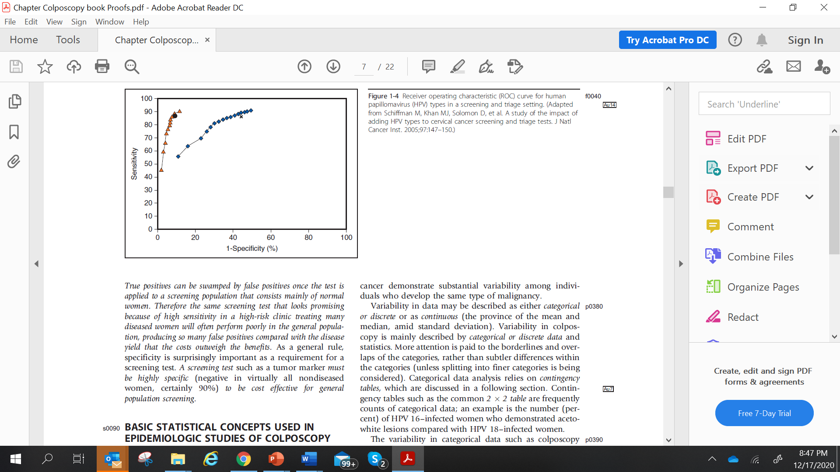

The assumption that they are constant and not affected by disease prevalence may only be correct in truly dichotomous disease status and if there is an homogenous probability of diagnostic misclassification within the population (diseased individuals and non-diseased individuals). Consequently, Sensitivity and Specificity estimates of diagnostic tests can only be compared if they are derived from populations in which disease prevalence distribution is comparable.

If the prevalence of the disease is very low, the PPV will not be close to 1 even if Se and Sp are high. In this situation, if the general population is screened, it is inevitable that many people with a positive result are truly false positives.

*Likelihood ratios*

From Se and Sp we can obtain the LR, which summarises how many times more (or less) are patients with the disease to have a particular result than patients without the disease (17). It indicates the value of the test for increasing certainty about a positive diagnosis.

* A positive likelihood ratio (LR+) tells us how many times more likely a positive test occurs in subjects with the disease than in those without the disease. The farther LR+ is from 1, the stronger evidence for the presence of the disease. LR above 10 are considered to provide enough strong evidence to confirm diagnosis in most of the circumstances. If LR+ is equal to 1, the test is not able to distinguish ill from healthy individuals. A high LR+ indicates that the test is useful, but it does not necessarily indicate that a positive test is a good indicator of the presence of disease.

LR+ = Se / (1-Sp)

* A negative likelihood ratio (LR-) tells us how much less likely the negative test result is to occur in a subject with the disease than in a healthy subject. LR- is usually less than 1 as it is less likely that a negative test result occurs in ill subjects than in healthy subjects. When LR is below 0.1, it is considered to provide enough evidence to exclude diagnosis in most of the circumstances. The lower LR- is, the stronger the evidence for the absence of disease.

LR- = (1-Se) / Sp

Since Se and Sp are used to calculate the LR, it is clear that both LR+ and LR- depend on disease prevalence.

*Receiver Operating Characteristic (ROC) curve*

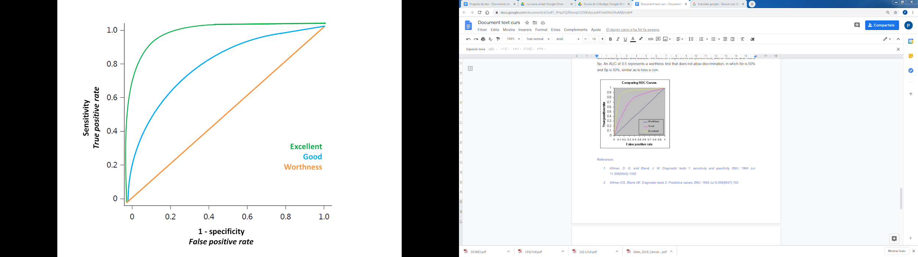Many diagnostic tests are quantitative and a cut-off point has to be established to distinguish health and disease status. The ROC curve is the representation of all the pairs of Sensitivity and Specificity values for a cutoff that could be established in the test evaluated.

On the ROC curve, the x-axis represents 1-Sp (the false positive rate) while the y axis represents Se (true positive rate) [Figure 4]. The shape of the ROC curve as well as the area under the curve (AUC) allows the estimation of how high the discriminative power of a test is: the closer the curve is located to the upper-left corner (highest sensitivity and specificity), the larger the AUC is and, therefore, the better the test is at discriminating health and disease. An AUC of 1 represents the perfect test, with a 100% Se and 100% Sp. An AUC of 0.5 represents a worthless test that does not allow discrimination, in which Se is 50% and Sp is 50%, similar as to toss a coin.

Finally, the overall diagnostic accuracy of a test is a global measure of the proportion of patients correctly identified among the total amount of subjects:

Overall diagnostic accuracy = (TP + TN) / total subjects

This measure is also affected by disease prevalence, and it increases as the disease prevalence decreases.

Also it is fundamental to report test accuracy using uncertainty measures such as 95% confidence intervals.

[IMPORTANT] An ideal screening test should have the maximum sensitivity and the maximum specificity, but in real life this is almost impossible to accomplish and screening tests do not classify patients perfectly. To achieve high sensitivity, specificity decreases and the opposite way. The prevalence of the majority of tumours among the population is low. Therefore, a decrease in the test specificity in order to maximize sensitivity, results in considerable increase of false positives that could lead to higher costs and to an increment of the adverse effects related to the screening tests. Thus, when assessing an screening test for an specific type of cancer among the general population the most relevant characteristic is a high PPV to detect the majority of the cases. This will, obviously, be at the cost of some false positives (lower specificity) as those false positives will be eliminated in further steps of the diagnostic procedure. In real life, the decision of the test might also consider the implications of being classified as positive or negative as well as whether additional diagnostic tests are available or not. In life-threatening diseases such as cancer, the main interest is that the subjects with disease are referred for further diagnosis, i.e. that they are not initially classified as false negatives.

A positive screening result is the initial step of a diagnostic process by means of referral to subsequent diagnostic tests (**triage tests**). Therefore, in the following step, when we are interested in confirming diagnosis, we will prioritize maximizing specificity over sensitivity, to correctly classify healthy subjects.

[Example] *HPV DNA for primary screening followed triage testing with cytology* (18)*.* In high-resource countries, HPV testing with triage to cytology is the current procedure for early diagnosis of cervical cancer. While HPV DNA testing shows high sensitivity and moderate specificity, it is used for screening followed by cytology as triage test, which presents low to moderate sensitivity but very high specificity.

## 2.3. Potential biases (lead time, length time, overdiagnose, etc)

### *Lead time bias*

Screening allows identifying disease earlier, so treatment can start at an early phase in order to imply a longer survival. However, this jump in the detection of the disease may imply a bias. A screening program is not useful when there is an increase in survival but not a prolongation in life (2). For example, subject B appears to survive longer than subject A, but only because the disease was identified earlier [Figure 2].

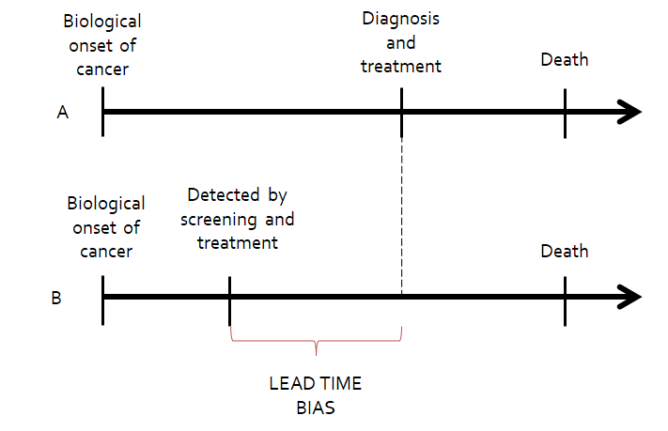

### *Length time bias*

Some cancers may have longer detectable preclinical phases than others, while others may be more aggressive and rapidly progress (2). Screening will probably detect those cancers with longer detectable preclinical phases, which are more likely to be more indolent than those that are not detected by screening [Figure 3].

Overdiagnosis bias is an extreme form of length-time bias (10). The detection of very indolent tumours in the screened group produces apparent increases in the number of cancer cases. Randomised trials with mortality rates as the endpoint can overcome lead and length-time biases.

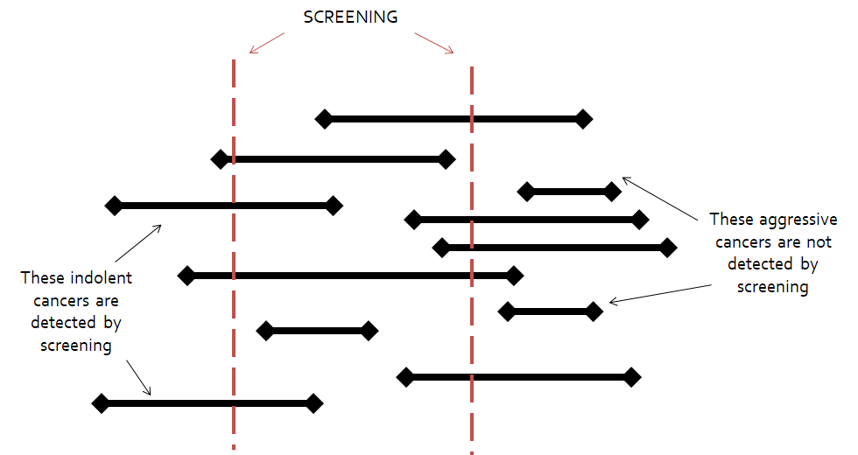

[Example]: Impotence and incontinence are common side effects of usual therapy for prostate cancer. These consequences will outweigh the alternative in aggressive forms of prostate cancer. However, a considerable proportion of men with prostate cancer have slow-growing tumours that would have been unlikely to be diagnosed or cause harm (11).

***Selection bias***

A self-selection bias may occur because participants may be healthier and adhere better to cancer prevention recommendations, as well as to therapy when they are cancer patients. Similarly, patients with higher cancer risk because of a family history of cancer may attend more frequently to screening programs (12). Therefore the outcomes associated with these populations may be better and bias the apparent value of the screening program.

**Module 2: Cancer prevention**

# Unit: 4. Overall program characteristics

## 2.1. Opportunistic vs organized screening programs

* An organized screening is a population-based programme designed by a central public health structure (national or regional) to reach the highest possible coverage of women. All women in the target age group are invited to participate. IARC defines an organized screening programme as one that has “an explicit policy with specified age categories, method, and interval for screening; a defined target population; a management team responsible for implementation; a health-care team for decisions and care; a quality assurance structure; and a method for identifying cancer occurrence in the target population” (4).
* Opportunistic, or spontaneous screening is done independently of an organized or population-based programme. Women are invited to participate when visiting health services for their convenience. Screening may be recommended by a provider during a consultation, or requested by a woman.

Organized screening is considered to be more efficient than opportunistic screening, given that it implies a better use of available resources and it benefits a greater number of people (5–7) . The choice of the target age group and the frequency of screening are usually made at the national or regional level. Opportunistic screening incurs more frequently in access biases, with low screening coverages in certain population groups (high-risk groups, certain ages, groups with low economic resources) and overuse in other groups. This implies a decrease in the effectiveness of the program and its profitability.

[Practical exercise 1]

*Click the boxes below:*

Organized screening:

... is the most efficient screening delivery system in countries or settings with a publicly-funded healthcare system. Organized screening ensures high and equitable coverage, as well as high quality of the processes involved. This implies implementing an information system that identifies all individuals at risk for the disease and instituting a call-recall system to reach all members of the target age group.

... is generally accepted as more cost-effective than opportunistic screening, making better use of available resources and ensuring that the greatest number of women benefit.

Opportunistic screening

... tends to reach younger women at lower risk, for example those attending antenatal, child health and family planning services.

... tends to be inefficient, though when applied with full adherence to professional guidelines it can also achieve a high reduction in disease incidence and mortality.

[Summary table 1]

|  |  |
| --- | --- |
| **Population screening** | **Opportunistic screening** |
| • Organized implementation of the diagnostic and early treatment activities in pre-defined groups of the population at risk. | • It is offered only to subjects that voluntarily attend health services, either with the purpose to get screened or for consultation reasons other than screening. |
| • The targeted population is clearly defined (subjects to be screened are identifiable). | • Its lack of organization penalizes equity, since subjects not requiring consultation do not get screened. |
| • It generally uses a census registry to invite the target population with recall systems for non-attendees. | • It creates methodological confusion between screening and clinical practice, which is hardly efficient and efficacious. |
| • Only offers validated screening techniques and has its own referral, treatment and follow-up algorithms of detected cases. | • Tends to unnecessarily repeat the screening test and sufficient levels of coverage are difficult to reach. |
| • The programme evaluation and monitoring are defined and planned, so incidence and mortality rates can be calculated separately for screening program participants and non-participants at the total targeted population level. | • Is potentially more expensive than any population-based screening design and the results of its implementation are difficult to assess. |
| • Furthermore, it establishes quality control of these epidemiological data. |  |

What is necessary to organize a cancer screening programme?

* A defined target population.
* A defined age to initiate screening, target age group for screening efforts, screening interval, screening test(s) to use.
* Effective recruitment strategies to achieve high coverage.
* A health care system with the capacity to screen, follow-up those who screened positive, and provide treatment as indicated.
* A quality control system.
* A health information system.
* A management team responsible for planning and implementation.

[KEY MESSAGE]: Screening is a programme, not a test.

**Module 2: Cancer prevention**

**Unit:** **1.n. Summary**

* Screening consists of the systematic application of safe, easy-to-use and economically affordable tests, to provide early detection of disease. Screening aims at reducing the disease prevalence by shortening its duration, to reduce the incidence of complications associated with the disease and to increase the quality of life of those affected by the disease.
* Organized screening is a population-based programme designed by a central public health structure (national or regional) to reach the highest possible coverage of women. Opportunistic, or spontaneous screening is done independently of an organized or population-based programme. Women are invited to participate when visiting health services for their convenience.
* Diagnostic test accuracy measures informs about the test ability to: 1) discriminate health and disease status in order to classify people between those who are ill and those who are not (sensitivity and specificity); 2) predict disease: estimation of the post-test probability of disease given a certain test result (predictive values).
* Several items are needed to organize a cancer screening programme, including a defined target population; defined age intervals and screening test(s) to use; a health care system with the capacity to screen, follow-up those who screened positive, and provide treatment as indicated; and quality control systems, among others.

Up until here MAXIMUM 12,5 pages

|  |
| --- |
| Title: Final Evaluation Module 2 |

**[Question 1] About cancer prevention, which of the following statements is true?**

* [Option A] Use of cytology within a cervical cancer screening programme is an example of secondary prevention.
* [Option B] HPV vaccination is an example of primary prevention.
* [Option C] Secondary prevention efforts are aimed at reducing disease incidence.
* [Option D] Screening focuses on disease detection at a clinical stage

[Correct Answer] **Option A**

**[Question 2] An screening test needs to be:**

* [Option A] Accurate and reliable
* [Option B] Acceptable and safe
* [Option C] Simple, cheap and accessible
* [Option D] All the above are correct

[Correct Answer] **Option D**

**[Question 3] What is the sensitivity of a screening test?**

* [Option A] The proportion of disease-free individuals (classified as negative by the gold standard) correctly identified by the screening test.
* [Option B] The proportion of subjects with disease (classified as positive) correctly identified by the screening test.
* [Option C] The proportion of true negatives (i.e. subjects without actual disease) among those identified by the test as negatives.
* [Option D] The probability that a subject with a negative test result has the disease.

[Correct Answer] **Option B**

**[Question 4] What is the negative predictive value of a screening test?**

* [Option A] The proportion of disease-free individuals (classified as negative by the gold standard) correctly identified by the screening test.
* [Option B] The proportion of subjects with disease (classified as positive) correctly identified by the screening test.
* [Option C] The proportion of true negatives (i.e. subjects without actual disease) among those identified by the test as negatives.
* [Option D] The probability that a subject with a negative test result has the disease.

[Correct Answer] **Option C**

**[Question 5] Which one of the following statements is not a requirement that any cancer screening test must meet?**

* [Option A] It must be a reliable and accurate test.
* [Option B] It must be economically affordable, acceptable, cause the least discomfort possible and not cause complications.
* [Option C] It must have a high specificity even if it implies low sensitivity.
* [Option D] It must be accessible to the entire target population

[Correct Answer] **Option C**

**[Question 6] Which answer is false regarding the differences between population-based and opportunistic screening programs?**

* [Option A] An opportunistic screening is more efficient that a population-based screening because it makes better use of available resources.
* [Option B] An opportunistic screening can lead to inequality situations, such as an excessive screening of subjects at low risk of developing the disease and insufficient screening of those at high risk.
* [Option C] Lack of participation is the main cause of lack of success of both opportunistic or population-based screening programs.
* [Option D]None of the above are correct

[Correct Answer] **Option A**

**[Question 7] Why are quality controls in cervical cancer screening important?**

* [Option A] To ensure reliability and accuracy of the results obtained through screening activities.
* [Option B] To identify possible errors or failures in the sample processing system.
* [Option C] A and B are correct.
* [Option D]None of the above are correct

[Correct Answer] **Option C**

**[Question 8] Why is it important to evaluate a cancer screening programme**

* [Option A] To ensure the adequate programme implementation and performance throughout the territory.
* [Option B] To justify the health costs involved.
* [Option C] All are correct.
* [Option D] None of the above are correct

[Correct Answer] **Option A**

**[Question 9] Which one of these statements is correct:**

* [Option A] Screening programs are exempt of bias
* [Option B] Lead time bias occurs because healthier participants adhere better to cancer prevention recommendations
* [Option C] Overdiagnosis bias is an form of length-time bias
* [Option D] None of the above are correct

[Correct Answer] **Option C**

**[Question 10] Which is NOT one of the 10 Wilson and Jungner principles of screening**

* [Option A] There should be a recognizable latent or early symptomatic stage.
* [Option B] The test should be highly reliable even if it is not very acceptable to the population.
* [Option C] The condition sought should be an important health problem.
* [Option D] Facilities for diagnosis and treatment should be available.

**Module 2: Cancer prevention**

**Unit: Bibliography**

**[Bibliography]**

1. Principles of Epidemiology | Lesson 1 - Section 9 [Internet]. 2020 [cited 2020 Nov 20]. Available from: http://www.cdc.gov/csels/dsepd/ss1978/lesson1/section9.html

2. Eeles RA, Tobias JS, Berg CD, editors. Cancer prevention and screening: concepts, principles and controversies. Hoboken, NJ: Wiley; 2018. 1 p.

3. Schüz J, Espina C, Villain P, Herrero R, Leon ME, Minozzi S, et al. European Code against Cancer 4th Edition: 12 ways to reduce your cancer risk. Cancer Epidemiol. 2015 Dec;39 Suppl 1:S1-10.

4. IARC. IARC Handbooks of Cancer Prevention. PREAMBLE FOR SCREENING. Lyon, France; 2009.

5. Diaz M, Moriña D, Rodríguez-Salés V, Ibáñez R, Espinás JA, de Sanjosé S. Moving towards an organized cervical cancer screening: costs and impact. Eur J Public Health. 2018 01;28(6):1132–8.

6. Schiller-Fruehwirth I, Jahn B, Einzinger P, Zauner G, Urach C, Siebert U. The Long-Term Effectiveness and Cost Effectiveness of Organized versus Opportunistic Screening for Breast Cancer in Austria. Value Health. 2017;20(8):1048–57.

7. Dubé C. Organized Screening Is Better Than Opportunistic Screening at Decreasing the Burden of Colorectal Cancer in the United States. Gastroenterology. 2018;155(5):1302–4.

8. Wilson J, Jungner G. Principles and practice of screening for disease [Internet]. Geneva, Switzerland: World Health Organization - WHO; 1968 [cited 2018 Mar 21]. Available from: http://apps.who.int/iris/bitstream/10665/208882/1/WHO_PA_66.7_eng.pdf

9. Andermann A. Revisiting Wilson and Jungner in the genomic age: a review of screening criteria over the past 40 years. Bulletin of the World Health Organization. 2008 Apr 1;86(4):317–9.

10. Jacklyn G, Bell K, Hayen A. Assessing the efficacy of cancer screening. Public Health Res Pract [Internet]. 2017 [cited 2020 Nov 21];27(3). Available from: http://www.phrp.com.au/?p=36695

11. Bunting PS. Screening for prostate cancer with prostate-specific antigen: beware the biases. Clin Chim Acta. 2002 Jan;315(1–2):71–97.

12. Cox B, Sneyd MJ. Bias in breast cancer research in the screening era. Breast. 2013 Dec;22(6):1041–5.

13. Gray JAM. New concepts in screening. British Journal of General Practice. 2004;7.

14. Altman DG, Bland JM. Statistics Notes: Diagnostic tests 1: sensitivity and specificity. BMJ. 1994 Jun 11;308(6943):1552.

15. Altman DG, Bland JM. Diagnostic tests 2: Predictive values. BMJ. 1994 Jul 9;309(6947):102.

16. Brenner H, Gefeller O. Variation of sensitivity, specificity, likelihood ratios and predictive values with disease prevalence. Stat Med. 1997 May 15;16(9):981–91.

17. Deeks JJ, Altman DG. Diagnostic tests 4: likelihood ratios. BMJ. 2004 Jul 17;329(7458):168–9.

18. Thomsen LT, Kjær SK, Munk C, Frederiksen K, Ørnskov D, Waldstrøm M. Clinical Performance of Human Papillomavirus (HPV) Testing versus Cytology for Cervical Cancer Screening: Results of a Large Danish Implementation Study. Clin Epidemiol. 2020;12:203–13.

19. Costas L, Frias-Gomez J, Guardiola M, Benavente Y, Pineda M, Pavón MÁ, et al. New perspectives on screening and early detection of endometrial cancer. Int J Cancer. 2019 15;145(12):3194–206.

20. Diaz M, de Sanjosé S, Bosch FX, Bruni L. Present challenges in cervical cancer prevention: Answers from cost-effectiveness analyses. Rep Pract Oncol Radiother. 2018 Dec;23(6):484–94.

21. Arbyn M, Anttila A, Jordan J, Ronco G, Schenck U, Segnan N, et al. European Guidelines for Quality Assurance in Cervical Cancer Screening. Second Edition—Summary Document. Annals of Oncology. 2010 Mar 1;21(3):448–58.

22. von Karsa L, Arbyn M, De Vuyst H, Dillner J, Dillner L, Franceschi S, et al. European guidelines for quality assurance in cervical cancer screening. Summary of the supplements on HPV screening and vaccination. Papillomavirus Research. 2015 Dec;1:22–31.

**Module 2: Cancer prevention**

**Unit: Additional Material**

**[Additional Material]**

* Bandos AI, Rockette HE. Use of likelihood ratios for comparisons of binary diagnostic tests: Underlying ROC curves. Med. Phys. 37 (11):5821-5830.
* Dobrow, Mark J., Victoria Hagens, Roger Chafe, Terrence Sullivan, and Linda Rabeneck. Consolidated Principles for Screening Based on a Systematic Review and Consensus Process. CMAJ 190, no. 14 (9 April 2018): E422–29. https://doi.org/10.1503/cmaj.171154.
* Hofvind S, ponti A, Patnick J, et al. False-positive results in mammographic screening for breast cancer in Europe: a literature review and survey of service screening programmes.J Med Screen. 2012;19 Suppl 1:57-66.
* Public Health England. Criteria for appraising the viability, effectiveness and appropriateness of a screening programme. Accessible at: https://www.gov.uk/government/publications/evidence-review-criteria-national-screening-programmes/criteria-for-appraising-the-viability-effectiveness-and-appropriateness-of-a-screening-programme. Last access: 20/11/2020
* World Health Organization. WHO report on cancer: setting priorities, investing wisely and providing care for all. Geneva, Switzerland: World Health Organization; 2020.
* World Health Organization. Comprehensive cervical cancer control: a guide to essential practice (2nd edition). Geneva: WHO editions., 2014